**MySQL Aggregate Function: Exercise-1 with Solution**

1. Write a query to list the number of jobs available in the employee’s table.

[SELECT](http://localhost/phpmyadmin/url.php?url=https://dev.mysql.com/doc/refman/8.0/en/select.html) [COUNT](http://localhost/phpmyadmin/url.php?url=https://dev.mysql.com/doc/refman/8.0/en/aggregate-functions.html%23function_count)(DISTINCT JOB_ID) FROM employees;



1. Write a query to get the total salaries payable to employees.

[SELECT](http://localhost/phpmyadmin/url.php?url=https://dev.mysql.com/doc/refman/8.0/en/select.html) [SUM](http://localhost/phpmyadmin/url.php?url=https://dev.mysql.com/doc/refman/8.0/en/aggregate-functions.html%23function_sum)(SALARY) FROM employees;

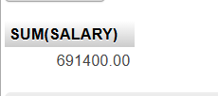

1. Write a query to get the minimum salary from employees table.

[SELECT](http://localhost/phpmyadmin/url.php?url=https://dev.mysql.com/doc/refman/8.0/en/select.html) [MIN](http://localhost/phpmyadmin/url.php?url=https://dev.mysql.com/doc/refman/8.0/en/aggregate-functions.html%23function_min)(SALARY) FROM employees;



1. Write a query to get the maximum salary of an employee working as a Programmer.

[SELECT](http://localhost/phpmyadmin/url.php?url=https://dev.mysql.com/doc/refman/8.0/en/select.html) [MAX](http://localhost/phpmyadmin/url.php?url=https://dev.mysql.com/doc/refman/8.0/en/aggregate-functions.html%23function_max)(SALARY) FROM employees;



1. Write a query to get the average salary and number of employees working the department 90.

[SELECT](http://localhost/phpmyadmin/url.php?url=https://dev.mysql.com/doc/refman/8.0/en/select.html) [AVG](http://localhost/phpmyadmin/url.php?url=https://dev.mysql.com/doc/refman/8.0/en/aggregate-functions.html%23function_avg)(SALARY),[COUNT](http://localhost/phpmyadmin/url.php?url=https://dev.mysql.com/doc/refman/8.0/en/aggregate-functions.html%23function_count)(*) FROM employees WHERE DEPARTMENT_ID=90;

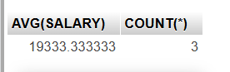

1. Write a query to get the highest, lowest, sum, and average salary of all employees.

[SELECT](http://localhost/phpmyadmin/url.php?url=https://dev.mysql.com/doc/refman/8.0/en/select.html) [MAX](http://localhost/phpmyadmin/url.php?url=https://dev.mysql.com/doc/refman/8.0/en/aggregate-functions.html%23function_max)(SALARY),[MIN](http://localhost/phpmyadmin/url.php?url=https://dev.mysql.com/doc/refman/8.0/en/aggregate-functions.html%23function_min)(SALARY),[SUM](http://localhost/phpmyadmin/url.php?url=https://dev.mysql.com/doc/refman/8.0/en/aggregate-functions.html%23function_sum)(SALARY),[AVG](http://localhost/phpmyadmin/url.php?url=https://dev.mysql.com/doc/refman/8.0/en/aggregate-functions.html%23function_avg)(SALARY) FROM employees;



1. Write a query to get the number of employees with the same job.

[SELECT](http://localhost/phpmyadmin/url.php?url=https://dev.mysql.com/doc/refman/8.0/en/select.html) JOB_ID, [COUNT](http://localhost/phpmyadmin/url.php?url=https://dev.mysql.com/doc/refman/8.0/en/aggregate-functions.html%23function_count)(*) FROM employees GROUP BY JOB_ID;

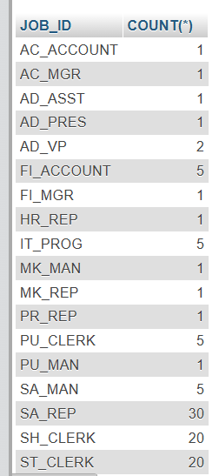

1. Write a query to get the difference between the highest and lowest salaries.

[SELECT](http://localhost/phpmyadmin/url.php?url=https://dev.mysql.com/doc/refman/8.0/en/select.html) [MAX](http://localhost/phpmyadmin/url.php?url=https://dev.mysql.com/doc/refman/8.0/en/aggregate-functions.html%23function_max)(SALARY) - [MIN](http://localhost/phpmyadmin/url.php?url=https://dev.mysql.com/doc/refman/8.0/en/aggregate-functions.html%23function_min)(SALARY) DIFFERENCE FROM employees;



1. Write a query to find the manager ID and the salary of the lowest-paid employee for that manager.

[SELECT](http://localhost/phpmyadmin/url.php?url=https://dev.mysql.com/doc/refman/8.0/en/select.html) MANAGER_ID, [MIN](http://localhost/phpmyadmin/url.php?url=https://dev.mysql.com/doc/refman/8.0/en/aggregate-functions.html%23function_min)(SALARY) FROM employees WHERE MANAGER_ID [IS](http://localhost/phpmyadmin/url.php?url=https://dev.mysql.com/doc/refman/8.0/en/comparison-operators.html%23operator_is) [NOT](http://localhost/phpmyadmin/url.php?url=https://dev.mysql.com/doc/refman/8.0/en/logical-operators.html%23operator_not) NULL GROUP BY MANAGER_ID ORDER BY [MIN](http://localhost/phpmyadmin/url.php?url=https://dev.mysql.com/doc/refman/8.0/en/aggregate-functions.html%23function_min)(SALARY) DESC;

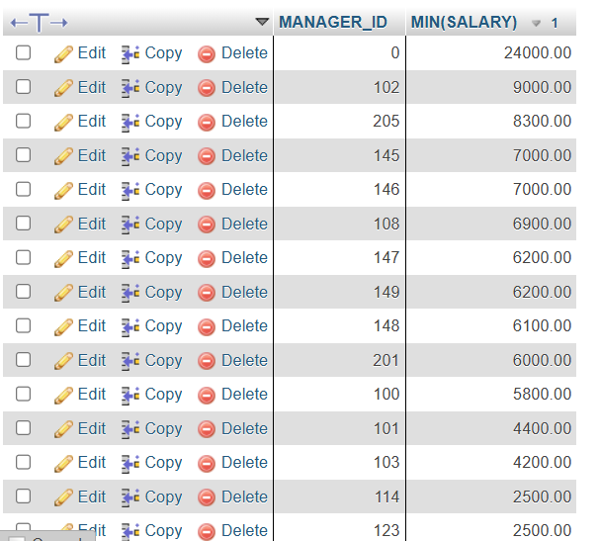

1. Write a query to get the department ID and the total salary payable in each department.

[SELECT](http://localhost/phpmyadmin/url.php?url=https://dev.mysql.com/doc/refman/8.0/en/select.html) DEPARTMENT_ID, [SUM](http://localhost/phpmyadmin/url.php?url=https://dev.mysql.com/doc/refman/8.0/en/aggregate-functions.html%23function_sum)(SALARY) FROM employees GROUP BY DEPARTMENT_ID;

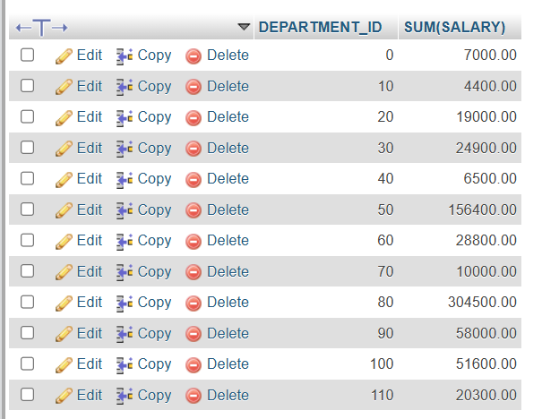

1. Write a query to get the average salary for each job ID excluding programmer.

[SELECT](http://localhost/phpmyadmin/url.php?url=https://dev.mysql.com/doc/refman/8.0/en/select.html) JOB_ID,[AVG](http://localhost/phpmyadmin/url.php?url=https://dev.mysql.com/doc/refman/8.0/en/aggregate-functions.html%23function_avg)(SALARY) FROM employees WHERE JOB_ID <> 'IT_PROG' GROUP BY JOB_ID;

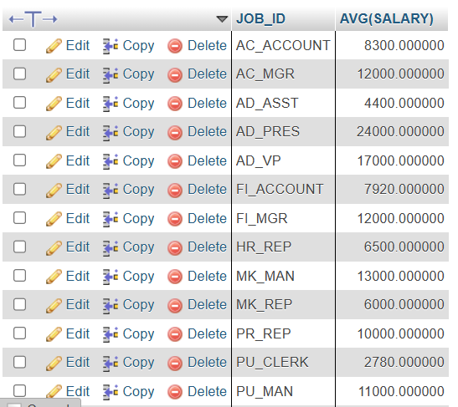

1. Write a query to get the total salary, maximum, minimum, average salary of employees (job ID wise), for department ID 90 only.

[SELECT](http://localhost/phpmyadmin/url.php?url=https://dev.mysql.com/doc/refman/8.0/en/select.html) [SUM](http://localhost/phpmyadmin/url.php?url=https://dev.mysql.com/doc/refman/8.0/en/aggregate-functions.html%23function_sum)(SALARY),[MAX](http://localhost/phpmyadmin/url.php?url=https://dev.mysql.com/doc/refman/8.0/en/aggregate-functions.html%23function_max)(SALARY),[MIN](http://localhost/phpmyadmin/url.php?url=https://dev.mysql.com/doc/refman/8.0/en/aggregate-functions.html%23function_min)(SALARY),[AVG](http://localhost/phpmyadmin/url.php?url=https://dev.mysql.com/doc/refman/8.0/en/aggregate-functions.html%23function_avg)(SALARY) FROM employees WHERE DEPARTMENT_ID =90 GROUP BY JOB_ID;

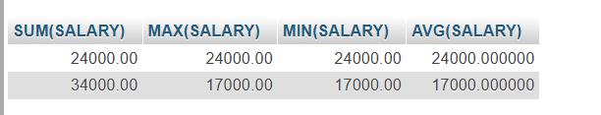

1. Write a query to get the job ID and maximum salary of the employees where maximum salary is greater than or equal to $4000.

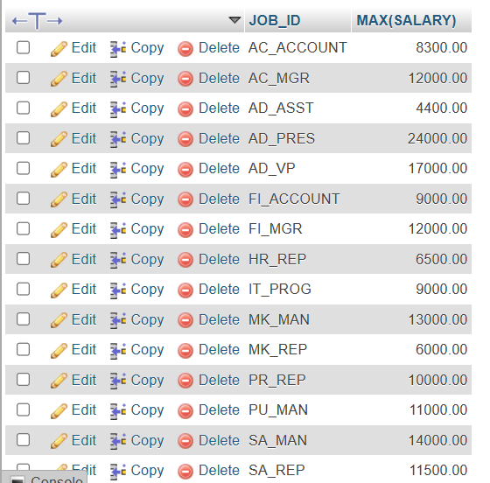

1. Write a query to get the average salary for all departments employing more than 10 employees.

[SELECT](http://localhost/phpmyadmin/url.php?url=https://dev.mysql.com/doc/refman/8.0/en/select.html) DEPARTMENT_ID, [AVG](http://localhost/phpmyadmin/url.php?url=https://dev.mysql.com/doc/refman/8.0/en/aggregate-functions.html%23function_avg)(SALARY), [COUNT](http://localhost/phpmyadmin/url.php?url=https://dev.mysql.com/doc/refman/8.0/en/aggregate-functions.html%23function_count)(*) FROM employees GROUP BY DEPARTMENT_ID HAVING [COUNT](http://localhost/phpmyadmin/url.php?url=https://dev.mysql.com/doc/refman/8.0/en/aggregate-functions.html%23function_count)(*) > 10;

